# **Analysis based on yara rule**

**List of samples:**

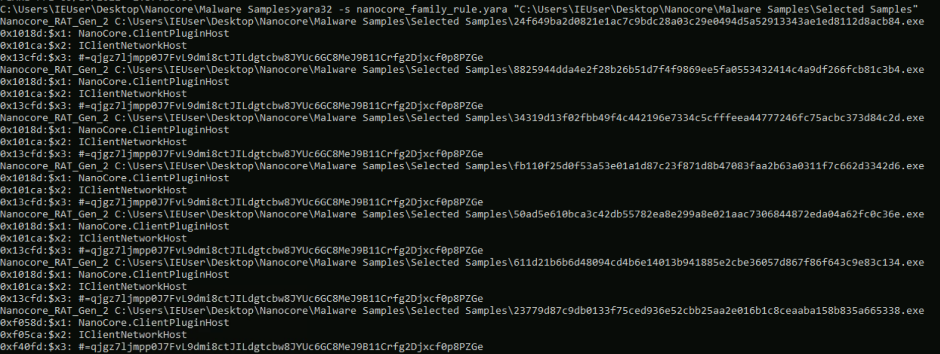

## **24f649ba2d0821e1ac7c9bdc28a03c29e0494d5a52913343ae1ed8112d8acb84.exe**

Screenshot PEstudio

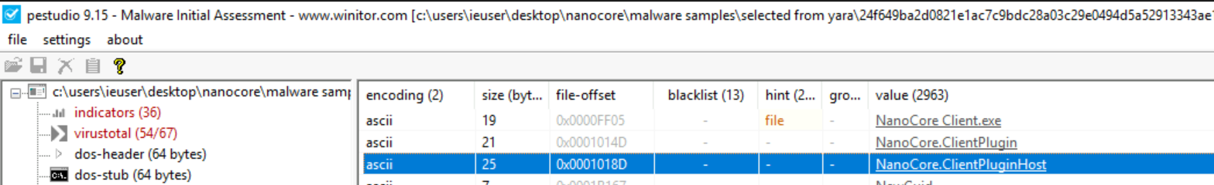

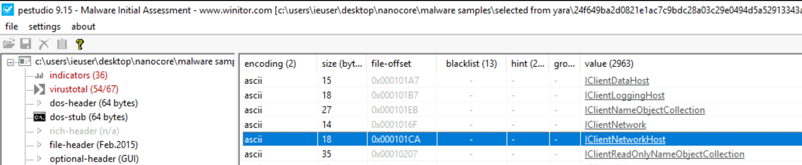

Screenshot Dynamic analysis

## **50ad5e610bca3c42db55782ea8e299a8e021aac7306844872eda04a62fc0c36e.exe**

Screenshot PEstudio

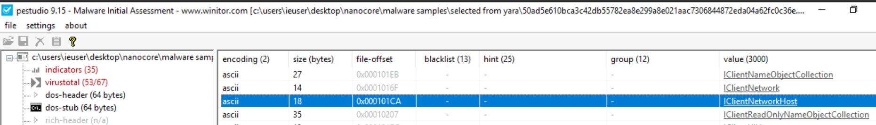

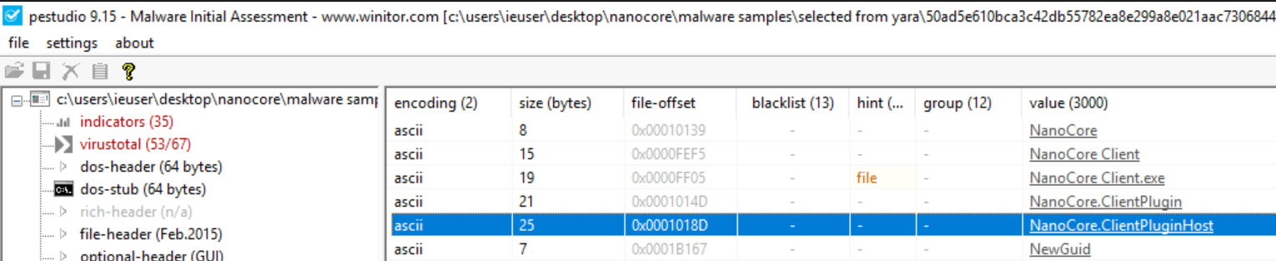

Screenshot Dynamic analysis

## **611d21b6b6d48094cd4b6e14013b941885e2cbe36057d867f86f643c9e83c134.exe**

Screenshot PEstudio

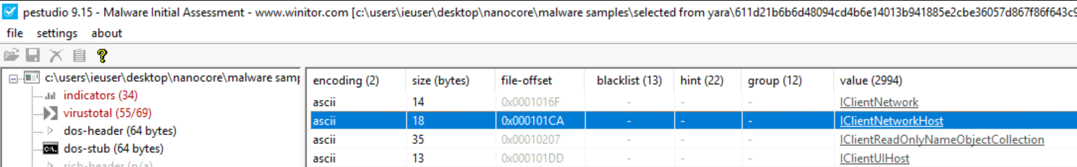

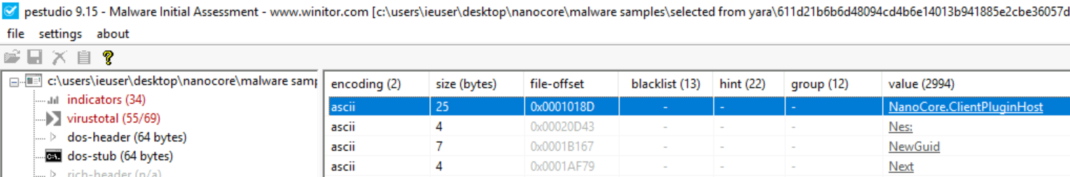

Screenshot Dynamic analysis

## **23779d87c9db0133f75ced936e52cbb25aa2e016b1c8ceaaba158b835a665338.exe**

Screenshot PEstudio

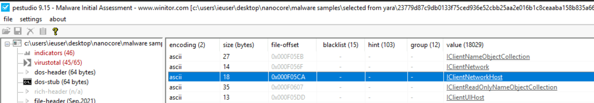

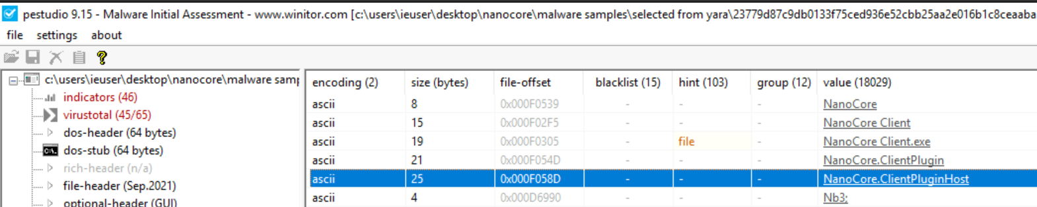

Screenshot Dynamic analysis

## **34319d13f02fbb49f4c442196e7334c5cfffeea44777246fc75acbc373d84c2d.exe**

Screenshot PEstudio

Screenshot Behaviors

## **8825944dda4e2f28b26b51d7f4f9869ee5fa0553432414c4a9df266fcb81c3b4.exe**

Screenshot PEstudio

Screenshot Behaviors

## **fb110f25d0f53a53e01a1d87c23f871d8b47083faa2b63a0311f7c662d3342d6.exe**

Screenshot PEstudio

Screenshot Behaviors